FootFusion

Use-Case Specification: Manage Shipping Process

Version 1.0

Revision History
Date | Version | Description | Author
26/11/2024 | 1.0 | Complete the final draft | Vu Thi Anh Thu

Table of Contents
1. Use-Case Name 2
1.1 Brief Description 2
2. Flow of Events 2
2.1 Basic Flow 2
2.2 Alternative Flows 2
2.2.1 < First Alternative Flow > 2
2.2.2 < Second Alternative Flow > 2
3. Special Requirements 2
3.1 < First Special Requirement > 2
4. Preconditions 2
4.1 < Precondition One > 2
5. Postconditions 2
5.1 < Postcondition One > 2
6. Extension Points 2
6.1 <Name of Extension Point> 2

Use-Case Specification: Manage Shipping Process

Manage Shipping Process

Brief Description
The primary purpose of the Manage Shipping Process use case is to enable Shop Owners to efficiently manage the shipping of buyer orders. This use case allows Shop Owners to review order details, verify buyer information, and select appropriate shipping options, ensuring that orders are delivered to customers accurately and on time. By optimizing the shipping workflow, it helps reduce delays, minimize shipping errors, and enhance the overall customer experience, ultimately improving satisfaction and ensuring reliable order fulfillment.

Flow of Events

Basic Flow
On the seller page, the checkout process is structured into four steps, listed from left to right: Information, Delivery, Payment, and Review. In the first step, the seller will view the customer’s contact information, including their first name, last name, email address, and phone number. To the right, the shipping address is displayed, with fields for the country, region, city, postal code, and street address. Below the address, there are two checkboxes for delivery and pickup, allowing the seller to select whether the customer wants the items delivered to their address or prefers to pick them up. The following section provides the order details, including the items, quantities, and prices. Once the seller has reviewed the order, they can proceed to the next step by clicking the "Continue Checkout" button.

In the Delivery step, the seller chooses a gift wrap option by selecting one of the available radio buttons. The options include wrap all items together, wrap each item separately, and wrap all items together. On the right side of the page, the seller selects their preferred delivery method by clicking on one of the available radio buttons. The order details, including item information, are displayed in the adjacent section. After making all necessary selections, the seller can click the "Continue Checkout" button to move on to the Payment section.

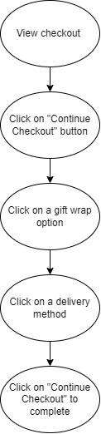

Alternative Flows
None.

Special Requirements
None.

Preconditions

Shop Owner Authentication
Shop owners must be logged into the system with valid credentials (username and password) to access and manage the shipping process for orders..

Postconditions

Shipping Information Updated
The shipping information of the order is updated in the system and moves to the next step.

Extension Points
NA.

Prototype
On the seller page, the checkout process is structured into four steps, listed from left to right: Information, Delivery, Payment, and Review. In the first step, the seller will view the customer’s contact information. To the right, the shipping address is displayed. Below the address, there are two checkboxes for delivery and pickup, allowing the seller to select whether the customer wants the items delivered to their address or prefers to pick them up. The following section provides the order details. Once the seller has reviewed the order, they can proceed to the next step by clicking the "Continue Checkout" button
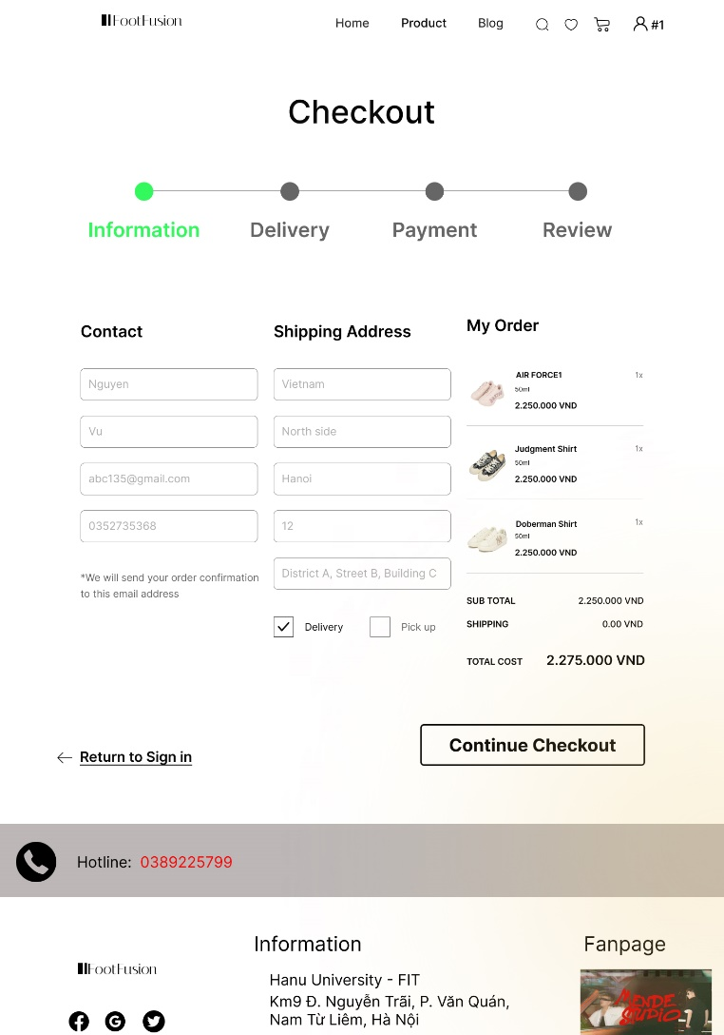

In the Delivery step, the seller chooses a gift wrap option by selecting one of the available radio buttons. On the right side of the page, the seller selects their preferred delivery method by clicking on one of the available radio buttons. The order details, including item information, are displayed in the adjacent section. After making all necessary selections, the seller can click the "Continue Checkout" button to move on to the Payment section
